List of experiments in computer networks

CSA0734

NAME: Y LOKESH

REG NO.:192111731

Experiment no:7

Configuration of hybrid topologies using packet tracer

### 

### AIM:

To establish of hybird topologies using packet tarcer

### 

### REQUIREMENTS:

1. End device - They are the devices through which we can pass message from one device to another and they are interconnected.
2. Switch/Hub - Interface Between two devices.
3. Cable - Used to connect two devices.

**Procedure:**

**STEP** 1: Click on end devices, select generic Pc’s drag and drop it on the window. Click on SWITCH drag and drop it on the window.

**STEP** 2: Select the straight through cable and connect all end device to switch. Assign

the IP address for all end devices. (Double click the end device Select →

desktop → IP configuration static)

**STEP** 3: Now set the IP address to Host A (192.168.1.1) in static mode. Similarly set

IP address for Host B (192.168.1.2) and Host C (192.168.1.3)

**STEP** 4: To view the IP address, give ipconfig command in command prompt. Using ping command, we can establish communication between two host devices.

**STEP** 5: Now display the packet transmission in simulation mode.

**Hybird topologies:**

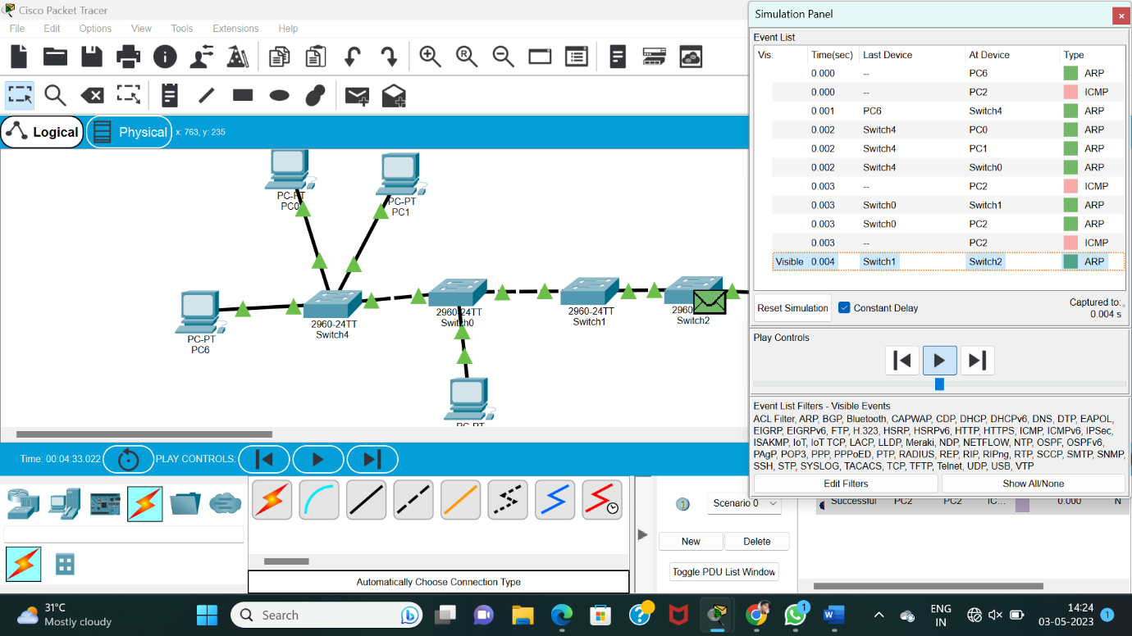

Result:

Configuration of Network hybird topologies using packet tracer verified successfully.